# Network Architecture & Technical Descriptions

## Text Analysis

Develop reading and interpretation skills using technical texts with focus on articles and prepositions. (Desenvolver leitura e interpretação de textos técnicos com foco em artigos e preposições).

Read the excerpt and observe the diagram below:  
"The server connects to the database through the main router. Clients access the application in the cloud."  
Leia o trecho e observe o diagrama abaixo:

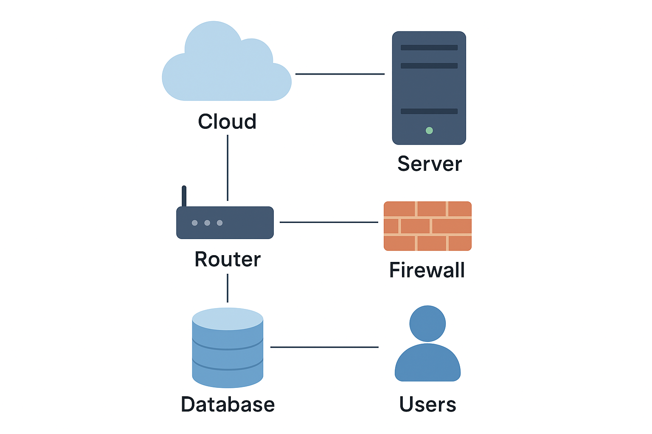

**Complete the sentences with A or THE:**

1. ______The______________ **server is hosted in** _____the__________ **cloud.**  
2. ____The____________ **data travels through** _____a________ **VPN.**  
3. **Python is** ______a___________ **language used for backend automation.**

## 2. Description Practice

**Practice describing system components using correct prepositions (between, under, on, in…).**

**Examples:  
- The router is between the server and the switch.  
- The backup database is under the main layer.**  
- Android is running a system based on Linux under the front-end

- The data travels between the server and the VPN

- C (programming language) runs on any system

- The RAM memory needs to be plugged on the computer

- Your SSD can be found in your motherboard

- The switch to turn your pc on is in your motherboard

## 3. Comparatives and Superlatives

**Compare technologies using correct comparative and superlative structures.**

**'Which Technology Wins?'  
  
Form three comparative and one superlative sentence about two technologies of your choice  
Examples:  
- AWS is more scalable than Azure.  
- Linux is the most secure system for developers.**

- Python is easier than C

- Javascript is the most used language for web development

- Cloud is more expensive than a local server

- ChatGPT is the most popular AI in the world

- Visual Studio Code is the best coding software for programming

- SQL is more well structured than NoSQL

## 4. Prefixes and Suffixes

**Expand technical vocabulary through prefixes and suffixes. (Ampliar o vocabulário técnico por meio de prefixos e sufixos pesquisando na internet).**

**Build new words using prefixes and suffixes.**

**Examples:**

**Load – reload**

**Configure - misconfigure**

**Connect –** disconnect

**Wire –** rewired

**Find 6 more:**

Change – Changeable

Poet – Poetic

Write – Rewrite

Kind – Unkind

Sense – Nonsense

Develop – Development

## 5. Practice

**Write a short paragraph describing a product (software or hardware), comparing it to another, and using at least three prepositions and comparative forms.**

Linux is becoming more popular nowadays. Not only between developers, but regular people are starting to use it now too. Why? It has less AI than Windows, it is faster, simpler, and is the most customized operation System in the world. For example, there some people that made a Hannah Montana Linux, a Justin Bieber Linux, a Linux for gaming and many others.